**Password Generator Project Report**

**Introduction:**

* The Password Generator project is designed to create secure and random passwords for users, enhancing online security. This web application generates passwords based on user-defined criteria and evaluates the strength of each generated password.

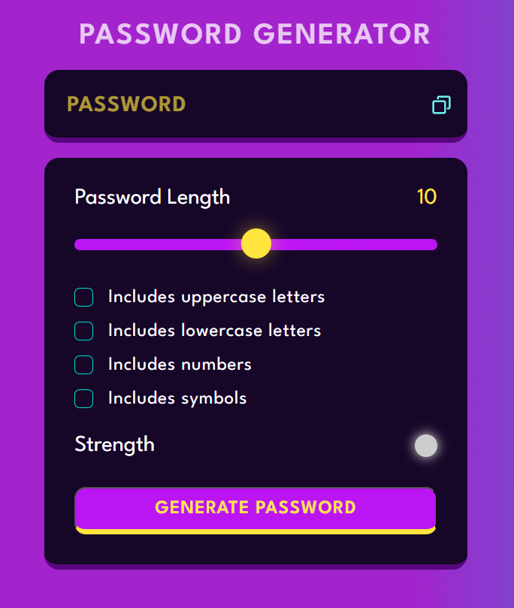 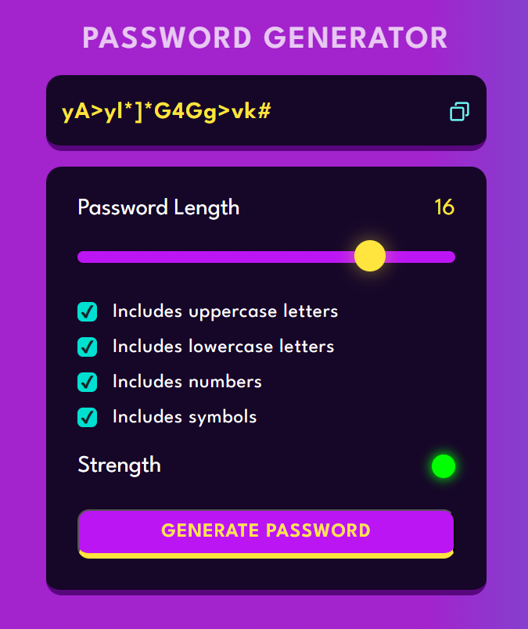

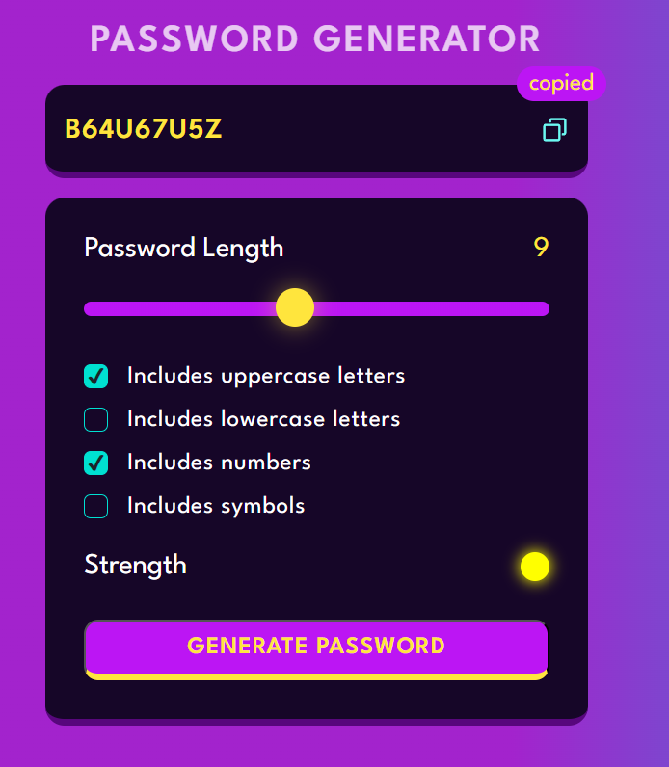

**Technologies Used:**

* **HTML**: For structuring the web page and defining the layout of the password generator interface.
* **CSS**: For styling the web page, including the password strength indicator, buttons, and overall design to enhance user experience.
* **JavaScript**: For implementing the functionality of password generation, strength evaluation, and dynamic updates to the user interface.

**Features:**

1. **Password Generation**: Users can click a button to generate a new password that meets specified criteria, including length and character types (uppercase letters, lowercase letters, numbers, and symbols).
2. **Password Strength Evaluation:** The application evaluates the strength of the generated password and indicates it with descriptive text. The strength levels are categorized as follows:

* **Good**: Indicated by a **Red** colour.
* **Very Good**: Indicated by a **Yellow** colour.
* **Strong**: Indicated by a **Green** colour.
* **Excellent**: Also indicated by a **Green** colour.
* **Default**: The indicator colour is **Grey** until a password is generated.

1. **Copy Button**: A "Copy" button allows users to easily copy the generated password to their clipboard for convenient use.

**Technical Implementation:**

* **HTML Structure**: The web page includes an input field for displaying the generated password, a button to trigger password generation, and a section to display password strength.
* **CSS Styling**: The password strength indicator is styled with different colours based on the strength of the generated password. This provides a visual representation of how secure the password is.
* **JavaScript Functionality**: The project uses JavaScript to handle the password generation logic, strength evaluation, and updating the user interface dynamically.

**JavaScript Functions:**

* **calcStrength(password)**: This function analyzes the generated password and returns a strength rating based on its length and complexity.
* **setText(strength)**: This function updates the user interface to display the strength of the password in text form and changes the indicator's colour accordingly.

**Conclusion:**

* The Password Generator project effectively provides users with a simple yet powerful tool for generating secure passwords. By incorporating features such as password strength evaluation and a copy functionality, it enhances user experience and promotes better security practices. Future enhancements could include additional customization options for password generation criteria and user interface improvements**.**

**Link:** [**https://83202.github.io/Password-Generator/**](https://83202.github.io/Password-Generator/)